AA Enterprise Framework Sample Illustration-1

**Problem statement**

Create a bot to get the temperature from Google for a list of cities stored in a csv file and write it to another csv file. The bot should recover automatically (atmost 2 times) in case of exceptions and log all actions and exceptions.

Steps:

1. Deploy framework in the respective folders in the Automation Anywhere Application path. Do retain the folder structure.
2. Populate/Add the necessary key-values in the Config.xlsx file.
   1. Set the value for ***MaxRetryCount*** as 3 .
   2. Set the value for ***TransactionItemsPath*** to the path of the csv file containing the list of cities.
      1. Set in this case as *C:\Users\U43360\Documents\Automation Anywhere Files\Automation Anywhere\Data\EnterpriseFramework Sample-1\ListOfTransactionItems.csv*
3. Open the workflow file ***EnterpriseFramework***for edit in Automation Anywhere Client.
4. Open the task ***Initialize***and do the following:
   1. Kill/Close all applications used in the automation use case.
      1. For this, Open the task ***CloseAllApplications*** and do the following:

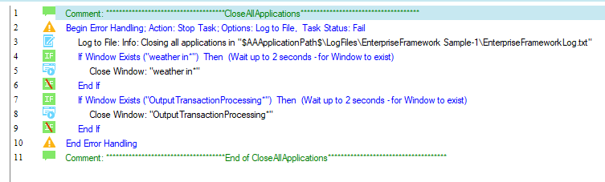

* 1. Open all applications used in the automation use case.
     1. For this, Open the task ***OpenAllApplications*** and do the following:

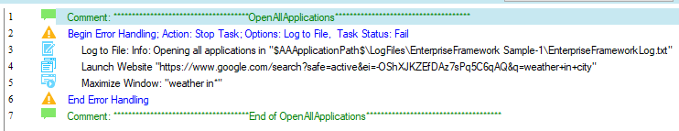

1. Open the task ***GetTransaction*** and do the following:
   1. Here, the transaction item is the city for which temperature should be retrieved for. The transaction id is the row index of the city in the csv file. The result is assigned to *vOutTransactionItem* as shown below. The status of the transaction is set to *Completed* when no item is found at the row whose index corresponds to the transaction id. This is expected when all transaction items are processed.

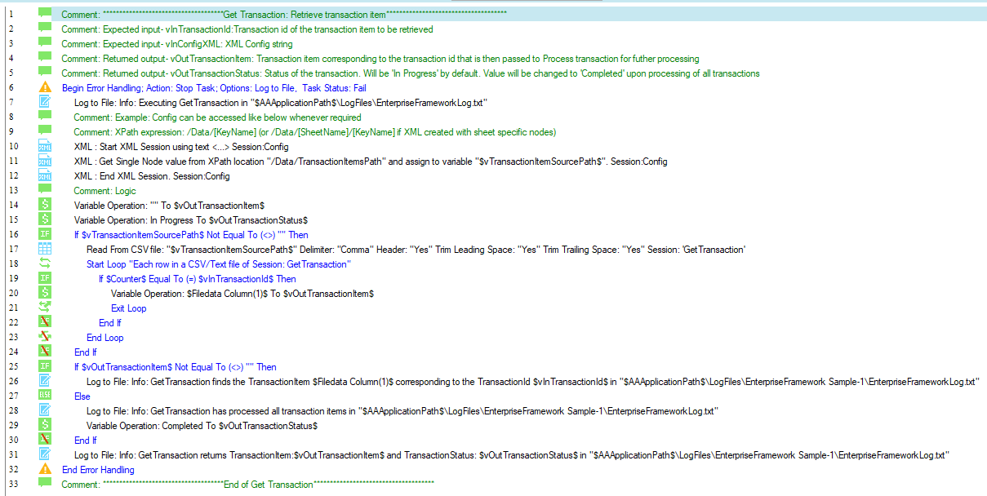

1. Open the task ***ProcessTransaction*** and do the following:
   1. Add commands to retrieve temperature from Google for the city retrieved in step #5 (transaction item) and write it to the corresponding csv file as shown below:

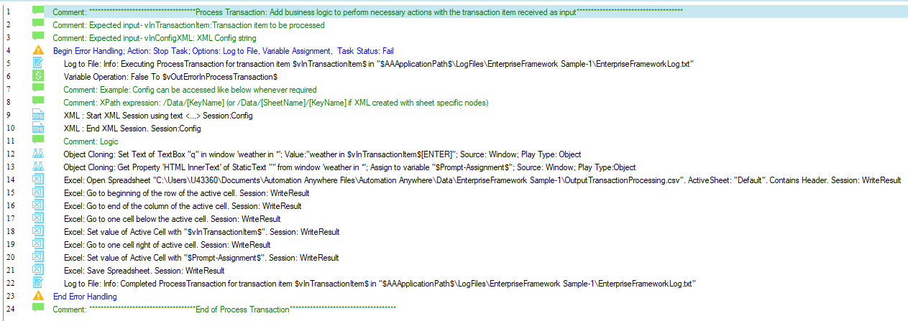

1. The task ***UpdateTransactionId*** will automatically run to iterate to the next transaction.
2. The task ***SetRetryCount*** will automatically initiate recovery mechanism.

**Solution:** 